Splunk Certified Core Power User : All-in-One Study Guide

Exam Foundation / Power User Mindset

When using SPL, Filter Early → Transform Late

Splunk Search Order of Operations

- Limit data (index, time, metadata)
- Filter (search, where)
- Extract / compute (eval, rex)
- Transform (stats, chart, timechart)
- Format (sort, table, head)

index=wineventlog sourcetype="WinEventLog:Security" EventCode=4625 earliest=-24h
| stats count AS failed_attempts by user, host
| sort - failed_attempts
| head 10

## PULL DATA FROM DISK
## SET SEARCH COMMAND
## SEARCH FUNCTIONS
## SEARCH ARGUMENTS

THE GOLDEN RULE OF SEARCH PERFORMANCE (ALWAYS SPECIFY…)
INDEX  ‎ index=wineventlog‎ ‎ | TIME RANGE  ‎ earliest=-24h‎ ‎ | SOURCETYPE/HOST  ‎ sourcetype=”x” || host=”y”‎ ‎

Search | Ad-hoc investigation  EX: Search: Investigate failed logins
Report | Saved search with visualization (i.e. Dashboard Visual)  Report: Daily failed login trend
Alert | Triggered action when condition met  Alert: >100 failures in 5 minutes

Search Modes
⚡Fast Mode | Field discovery OFF for Event Searches. No event or field data for stats searches  Performance, minimal fields
💡Smart Mode | Field discovery ON for Event searches. No event or field data for stats searches  Default, balances speed/detail
💬Verbose Mode | Returns ALL Event and Field data  All fields extracted, FULL PICTURE

Search Processing Language (SPL) Basics
Boolean Modifiers
AND | OR | NOT

Common Commands
stats | table | rename | dedup | sort
timechart | chart | top | rare | fillnull

Arguments
by | as | span | limit

Functions
sum() | avg() | min() | max() | tostring()

1.0 | Using Transforming Commands for Visualizations | 5%
1.1 Use the chart command

index=web earliest=-24h
| chart count by status, host

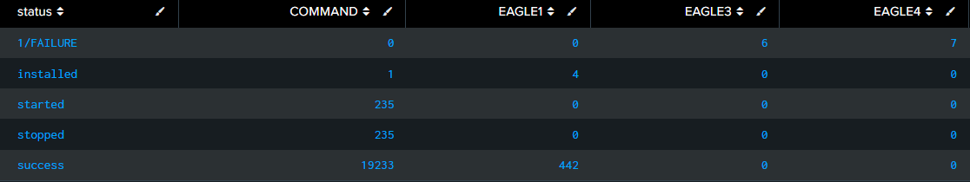
Makes a table showing counts grouped by two fields.
“Count how many red, blue, and green blocks each kid has.”
Exam Tip: NOT Time-Based, Use when you want two groupings

1.2 Use the timechart command

index=web earliest=-24h
| timechart span=1h count by status

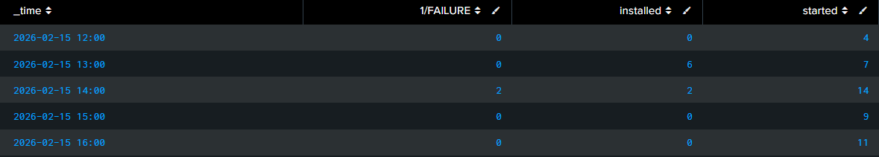
Shows count of something over time intervals.
“Show me how many cookies were eaten each hour.”
Exam Tip: Use when time is your X-axis

2.0 | Filtering and Formatting Results | 10%
2.1 The eval command

index=web
| eval severity=if(status>=500,"Critical","Normal")

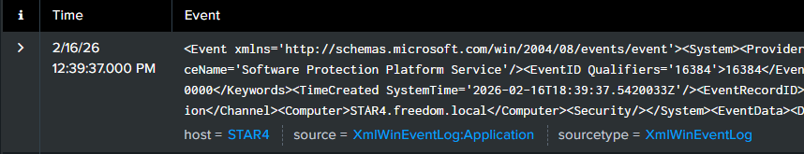
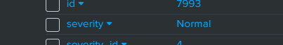

Creates or changes a field.
“If the number is big, call it ‘bad’.”
Exam Tip: “create,” “calculate,” “convert,” “classify,” or “modify a field” → the answer is almost always eval.

2.2 Use the search and where commands to filter results

index=web
| search EventCode=4624

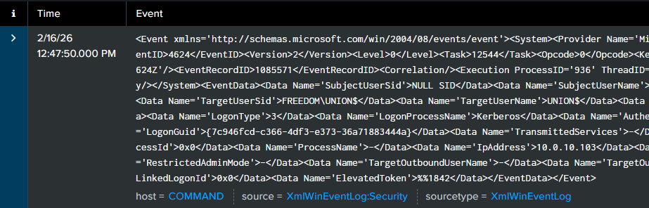
search = fast
search = “Find red apples”
Exam Tip: Use search first if possible (faster)

index=web
| where EventCode > 100

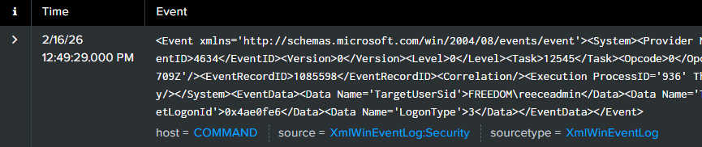
where = math or logic
where = “Find apples bigger than this”
Exam Tip: Use search first if possible (faster)
2.3 The fillnull command

index=web
| stats count by host
| fillnull value=0 count

Replaces empty values.
“If a box is empty, write zero instead.”
Exam Tip: “replace missing values,” “handle null values,” or “show 0 instead of blank” → use fillnull.

3.0 | Correlating Events | 15%
3.1 Identify transactions

index=web
| transaction session_id

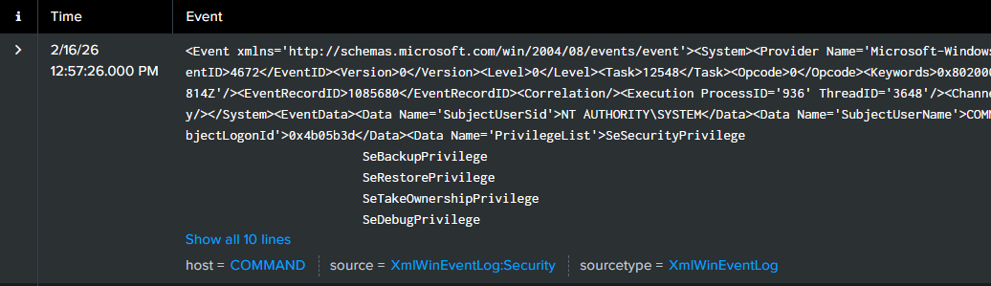Groups multiple events into a single session based on:
- A common field (user, session_id, host, etc.)
- Time proximity
- Event order
“Put all the toys from one kid into one bag.”
Exam Tip: “session,” “start and end events,” “sequence,” or “group related events in order” → transaction.

3.2 Group events using fields

index=web
| stats count by user ← “user” is a FIELD

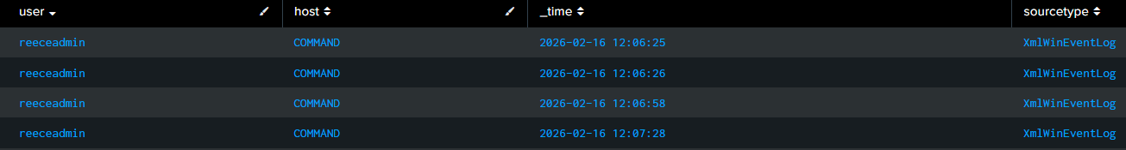
Group events by one of the several fields assigned (i.e. user, host, _time, etc.)
“Count how many toys each kid has.”
Exam Tip: “show only these columns,” “remove unnecessary fields,” or “limit the output fields” → fields

FIELDS | TAGS
Data assignments that already exist  “user” “host” “src_ip” “status” | Labels manually added to events  “tag=authentication” “tag=network” “tag=system”
3.3 Group events using fields and time (timechart)

index=web
| timechart span=1h count by user ← “span=1h” is a TIMESPAN inside the search TIMELINE
“user” is a FIELD

Grouping by time AND grouping by another field (user, host, status, etc.)
“Tell me how many cookies were eaten each hour, and show who ate them.”
Exam Tip: “trend over time,” “time interval,” or “per hour/day AND by a field” → almost always timechart.

3.4 Search with transactions

index=web
| transaction user maxspan=10m
| search eventcount > 5

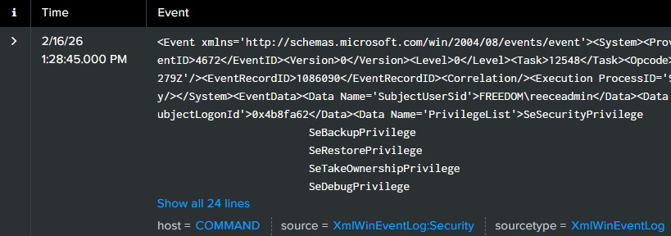
Find sessions with many events.

3.5 Report on transactions

index=web
| transaction user
| stats avg(duration) by user

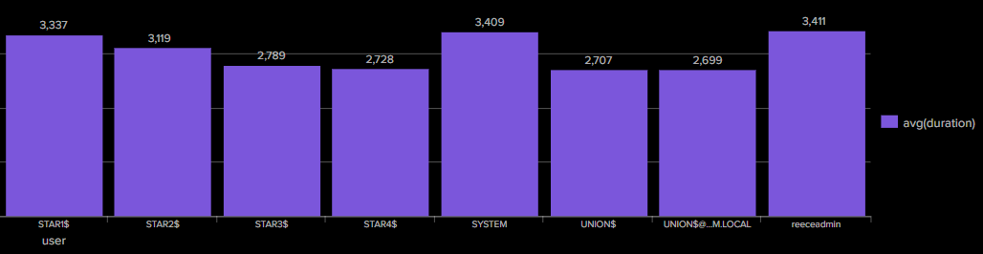

3.6 Determine when to use transactions vs. stats

| transaction |  |  | | stats
🐌SLOW… | Order Matters | Sessions | ⚡FAST!!! | Order Doesn't | Counts/Trends

| transaction |  |  | | stats
“watch the whole movie” |  |  | “count how many scenes in the movie”

Exam answer most of the time: use stats instead of transaction due to performance

4.0 | Creating and Managing Fields | 10%
What is the Field Extractor (FX)?

The FX is a Splunk tool that helps you create fields from raw event text using a guided interface (regex or delimiters).
“It turns messy text into searchable fields.”
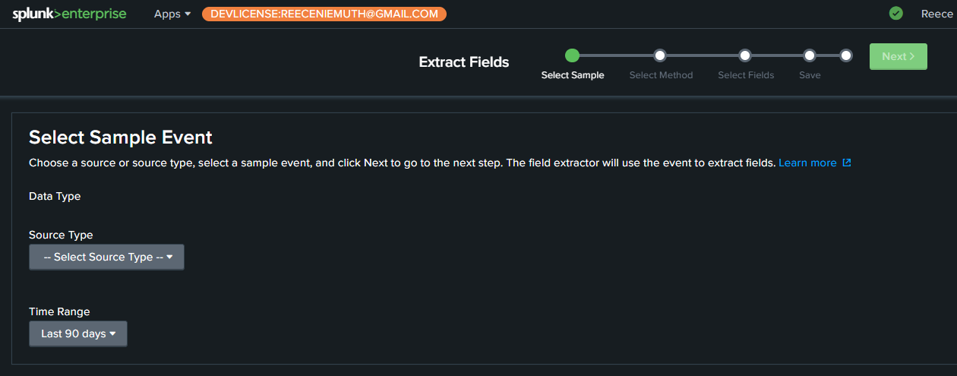

4.1 Perform regex field extractions (rex) using the Field Extractor (FX)

index=app
| rex "user=(?<user>\w+)"

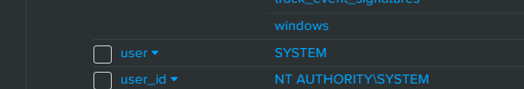
Extracts user from text.
“Find the name inside the sentence.”
Exam Tip: “extract a value from raw text,” “pattern match,” or “capture part of a string” → rex

4.2 Perform delimiter field extractions using the FX

If your logs look like this:
user,src_ip,status

Use the delimiter option:
Field Extractor → delimiter = comma ## OR the “,” plaintext character

“Split the sentence wherever there’s a comma, pipe, or other consistent character”

Exam Tip: data is separated by , | or other consistent character → use (Field Extractor – delimiter mode).

5.0 | Creating Field Aliases and Calculated Fields | 10%
5.1 Describe, create, and use field aliases

Example of a Field Alias:
client_ip → src_ip ## Manually Renamed Field Name (ALIAS for a Field)

A field alias lets you treat one field name as another field name.
“Two names for the same person.”
Exam Tip: “two fields mean the same thing” or “search using one common field name across different data sources” → Field Alias.

5.2 Describe, create, and use calculated fields

| eval response_time_sec=response_time/1000

A calculated field creates a new field automatically using an eval expression. (performs math, logic, conversions)
“Do math and save the answer as a new box.”
Exam Tip: “create a new field using a formula, condition, or conversion” → eval

6.0 | Creating Tags and Event Types | 10%
6.1 Create and use tags

Settings → Tags → (Choose Tag View) → ‎ Create New Tag‎ ‎
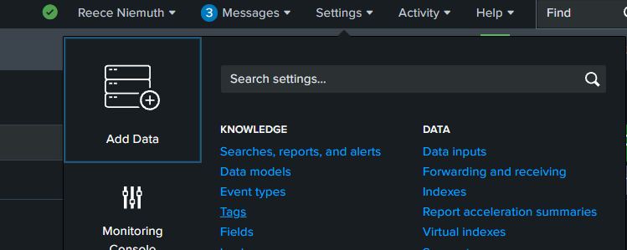

tag=failed_logins OR tag=privileged OR tag=system
Tags are labels assigned to events to categorize and filter them easily.
“Put a sticker on important events so you can find them later.”
Exam Tip: “label,” “categorize,” or “group related events” → use a Tag

6.2 Describe eventtypes and their uses

eventtype=failed_logins OR eventtype=sudo_usage OR eventtype=workstation_restart

## DEFINITION FOR eventtype=failed_logins
index=* (EventCode=4625 OR "Failed password" OR "authentication failure")
## DEFINITION FOR eventtype=sudo_usage
index=* "sudo:"
## DEFINITION FOR eventtype=workstation_restart
index=* ("system reboot" OR "shutdown" OR "starting up")
Event types are named search filters that automatically categorize events based on search criteria.

An event type is a named search used to classify events automatically

“A saved search name I can reuse”

Exam Tip: “create a reusable classification based on search criteria” → Create an eventtype.
6.3 Create an eventtype

Settings → Event types → New Event Type‎ ‎

- Assign Destination App (Where this event type will be saved, app visibility, scope ONLY no search logic)

- Name your eventtype (what the eventtype will be named, and used to call it in your SPL searches/logic)

- Create Search String Definition (The actual search that defines the event type.)

- (OPTIONAL) Create associated Tag (Labels automatically applied to events that match this event type.)

- (OPTIONAL) Assign Color to the eventtype (Visual highlight color for events, no effect on search behavior)

- Assign Priority, Lower number = higher priority. (Determines which event type wins if multiple event types match the same event.)

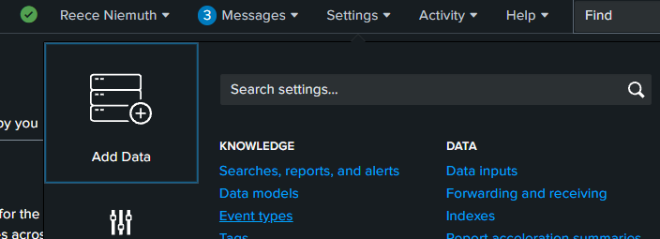

7.0 | Creating and Using Macros | 10%
7.1 Describe macros

A macro is a reusable piece of SPL that acts like a shortcut for a search.

Macro definition:
failed_logins ## MACRO NAME

Definition SPL:
EventCode=4625 ## MACRO “STORED QUERY”

Use it in a search:
index=wineventlog `failed_logins` ## MACRO “STORED QUERY” IN AN SPL SEARCH

MACRO VS EVENTTYPE | MACRO | EVENTTYPE
Reusable SPL snippet? | YES | NO
Used inside a search? | YES | NO
Saved search filter? | NO | YES

7.2 Create and use a basic macro

Settings → Advanced Search → Search Macros → New ‎Search Macro ‎
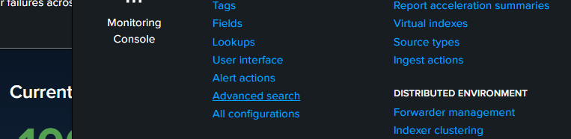
7.3 Define arguments and variables for a macro

A macro can accept inputs so it works in different situations (Instead of hardcoding values, you use variables.)

(Example) Instead of this fixed macro:
index=wineventlog EventCode=4625
I want to choose the index when I run it.

How Variables Work: Inside the macro definition, use:
$variable_name$

(Example) definition:
index=$index_name$ EventCode=4625
index_name = argument
$index_name$ = variable used in SPL

Variable = “A blank space you fill in when you press the shortcut.”

7.4 Add and use arguments with a macro

Settings → Advanced Search → Search Macros → New ‎Search Macro ‎ → “Arguments”

- Assign Destination App (Which app can use this macro)

- Name your macro (If it takes arguments, add the number:failed_logins(1) OR user_search(2)
(The shortcut name (and how many inputs it expects).)

- Create Search String Definition (The SPL the macro expands into)index=$index_name$ VARIABLE USE
- Create Arguments (Comma-separated names for inputs.)
  - Example: index_name,user_name
  - These become variables: $index_name$ AND $user_name$

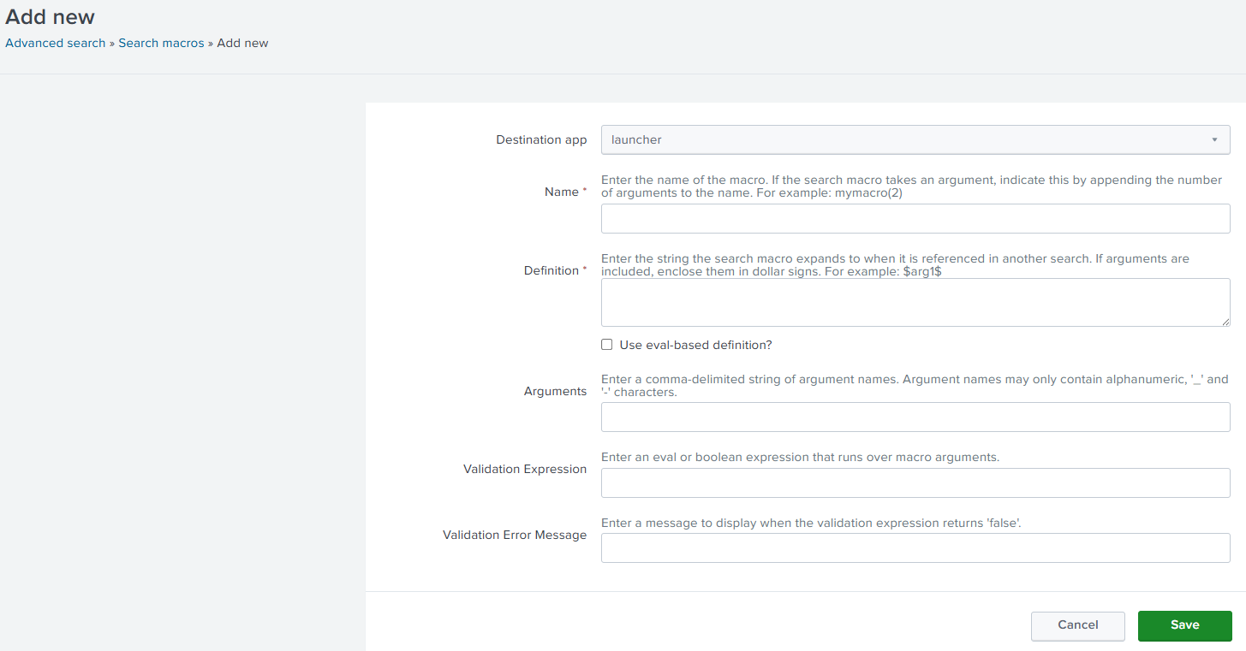

Arguments Example: (“The blanks/parameters you fill in when using the MACRO/method shortcut.”)
Argument | Definition | Used in Search
host_name | host=$host_name$ | `host_filter(server1)`

Validation Expression: A rule that checks if the argument is valid before running the macro.
len($host_name$)>0 ## ENSURES HOSTNAME AT LEAST 1 CHARACTER LONG

Validation Error Message: The message shown if validation fails.
The name of the Host MUST be AT LEAST 1 Character in length ## ERROR MESSAGE

8.0 | Creating and Using Workflow Actions | 10%
8.1 Describe the function of GET, POST, and Search workflow actions

Workflow actions let you click a field value in results and trigger an action.

Example: Click an IP → open VirusTotal.

8.2 Create a GET workflow action

Opens a URL and sends the field value in the URL.

Example: Click an IP → opens https://www.virustotal.com/gui/ip-address/10.1.1.5

“Click something → open a website about it.”

Exam Tip: “Open external website” “Pass value in URL” → GET

8.3 Create a POST workflow action

(Send Data to API) Example: Click IP → send to incident system

Configuration of POST workflow

Endpoint
https://soc-system/api/create_alert

POST Body
ip=$src_ip$&count=$count$

Behavior of POST workflow
Click here:
src_ip=10.1.1.5
count=42

System Receives:
ip=10.1.1.5
count=42

Exam Tip: POST = “Send field values externally”

8.4 Create a Search workflow action

Settings → Fields → Workflow actions → New ‎Workflow Action‎ ‎
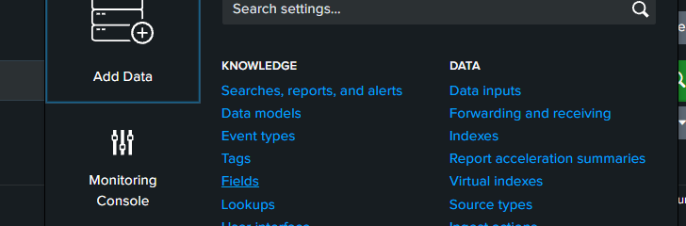

Use Case: Click IP → search all activity for that IP

Advanced Example
index=network (src_ip=$src_ip$ OR dest_ip=$src_ip$)
| stats count by host

Behavior = Click “src_ip=10.1.1.5“ → Splunk runs: ”index=* src_ip=10.1.1.5”

Exam Tip: Search Workflow = new investigation search
9.0 | Creating Data Models | 10%
9.1 Describe the relationship between data models and pivot

A data model is a structured, organized collection of data with predefined fields and relationships.

Pivot is a GUI tool that lets you build reports without writing SPL. (It pulls data from a data model.)

Data Model → Pivot → Report/Dashboard

Example Workflow
- Create Data Model: Authentication
- Open Pivot
- Choose Authentication
- Build Report
  - Count by User
  - Over Time

Behind the scenes, Splunk runs something like:
| tstats count from datamodel=Authentication by Authentication.user

Exam Tip: “Pivot uses Data Models to generate searches and visualizations.”

9.2 Identify data model attributes

1. Dataset - The main category of data. (Authentication Activity Logs or Network Traffic)
2. Fields - The data points themselves (user, src_ip, dest_ip, etc.)
3. Constraints - Filters that define what data belongs. (“index=wineventlog EventCode=4625”)
4. Acceleration (Performance Feature) - Speeds up searches, used with tstats
Example tstats Search
| tstats count from datamodel=Authentication where Authentication.action="failure"

Dataset = The category of something
Fields = The various details of that something
Constraints = What refines the scope of the something we are looking for

Exam Tip: “Fast searches” “Optimized performance” “tstats” → Data Model (accelerated)

9.3 Create a data model

- Go to Settings
- Click Data Models
- Click New Data Model
- Provide:
- Name
- App location
- Add Dataset
- Define:
- Constraints (search criteria)
- Fields
- Save
(Optional) Enable Acceleration

Using the Data Model (SPL) after creation:
| tstats count from datamodel=Failed_Logins by Failed_Logins.user

Creating a data model = “Make a clean box for specific types of data so it’s faster to search later.”

10.0 | Using the Common Information Model (CIM) Add-On | 10%
10.1 Describe the Splunk CIM

CIM (Common Information Model) is a standard way to organize and name data in Splunk. (It makes different data sources look the same.)

Example Problem: “Different names → hard to search!”
Firewall log:
source_ip=10.1.1.5

Windows log:
client_ip=10.1.1.5

CIM Solution: “Everyone uses the same labels so searches work everywhere.”
Map both to:
src=10.1.1.5
Now you can search:
src=10.1.1.5
Across all data!

CIM = “Everyone uses the same labels so searches work everywhere.”

Exam Tip: “Standardize field names” “Make data consistent across sources” “Normalize logs” → CIM

10.2 List the knowledge objects included with the Splunk CIM Add-On

Field Aliases | Map different field names to CIM fields
Field Extractions | Extract needed fields
Tags | Categorize events
Event Types | Define event categories
Lookups | Map values to standardized meanings

CIM Add-On = “A kit that adds the right labels automatically.”

Exam Tip: “What does CIM provide?” → Field aliases, Field extractions, Tags, Eventtypes, Lookups

10.3 Use the CIM Add-On to normalize data

What Normalization Means = “Take different vendor data and make it follow CIM field names.”

Search works across sources:
tag=authentication
| stats count by user, src
Even if original logs used:
- username
- user_name
- account
They all map to:
user

Exam Tip: “Search multiple vendors with one query” “Make data consistent” → Use CIM

Overview for Exam Preparation
❏ Working with Time
Always know how to control time using the time picker and earliest/latest.
Understand _time is the primary event timestamp.
Use timechart for time-based trends and know when to adjust span (e.g., span=1h, span=1d).

❏ Statistical Processing
Core commands: stats, timechart, chart.
Know common functions: count, sum, avg, min, max, dc.
Key idea: stats transforms events into aggregated results (raw events are no longer available after).

❏ Comparing Values
Use eval for logic and calculations.
Know conditional functions:
if(), case(), coalesce().
Use where for filtering based on field comparisons (post-search filtering).

❏ Result Modification
Clean and shape output using:
- table, fields (select columns)
- rename
- sort
- dedup
- fillnull
Exam focus: turning messy results into analyst-ready output.

❏ Correlation Analysis
Combine related events using:
- transaction (session-like grouping)
- stats with BY (preferred for performance)
Understand grouping by a common field (user, session, host) to detect patterns.

❏ Creating Knowledge Objects
Know what they are: saved searches, reports, dashboards, alerts, event types, tags, lookups.
Key exam concept: Permissions and sharing (Private, App, Global).

❏ Creating Field Extractions
Extract fields at search time using:
- Field Extractor (UI)
- Regex (rex)
Know the difference between automatic vs manual extractions.

❏ Data Models
Structured datasets used for fast, normalized searching.
- Understand datasets, objects, and fields
- Know they enable pivot and accelerated searches
- Used heavily with tstats for performance.
The Power User Workflow (Remember This)
Filter | Extract | Transform | Analyze | Present | Save
index=web | rex / auto fields | stats / chart | eval/case/stats | table/sort/dedup | Dashboard View

